**Software Solutions Now (SSN) Project Object Oriented Analysis:**

|  |  |  |
| --- | --- | --- |
| Class | Attribute | Method |
| Department | * code * name * hourlyRate * overtimeRate | * display * addDepartment * updateDepartment * viewSingleDepartment * viewAllDepartment * deleteDepartment |
| Employee | * id * firstName * lastName * departmentCode * position | * display * addEmployee * updateEmployee * viewSingleEmployee * viewSorted   deleteEmployee |

**Relations Diagram**

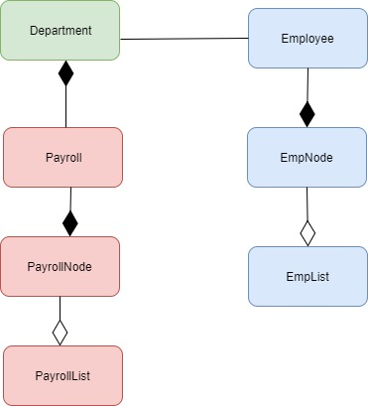

**Class Diagrams**

